Lab_Assignment_6.1.docx

2303a51246
Shiva

Task 1

Task Description #1 (AI-Based Code Completion for Loops)
Task: Use an AI code completion tool to generate a loop-based
program.
Prompt:
“Generate Python code to print all even numbers between 1 and N
using a loop.”
Expected Output:
• AI-generated loop logic.
• Identification of loop type used (for or while).
• Validation with sample inputs.

Prompt
# write a python code to Print all even numbers from 1 to N using loop
Code :
n = int(input("Enter N: "))
for i in range(2, n + 1, 2):
print(i)
output:
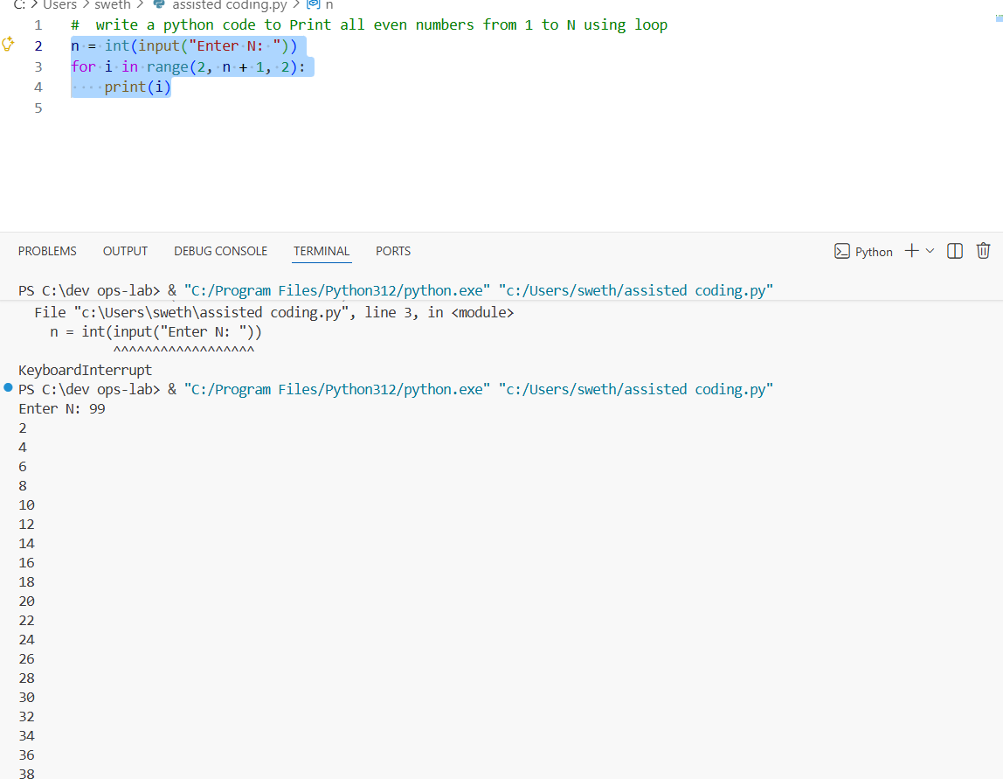

Task 2 :
Task Description #2 (AI-Based Code Completion for Loop with
Conditionals)
Task: Use an AI code completion tool to combine loops and
conditionals.
Expected Output:
• AI-generated code using loop and if condition.
• Correct count validation.
• Explanation of logic flow.

Promt:
# write a python code to print how many numbers in a list are even or odd
Code:
nums = input("Enter integers separated by spaces: ").strip()
if not nums:
print("No numbers provided.")
else:
try:
arr = [int(x) for x in nums.split()]
except ValueError:
print("Invalid input.")
else:
even = sum(1 for x in arr if x % 2 == 0)
odd = len(arr) - even
print("Even:", even)
print("Odd:", odd)

output:
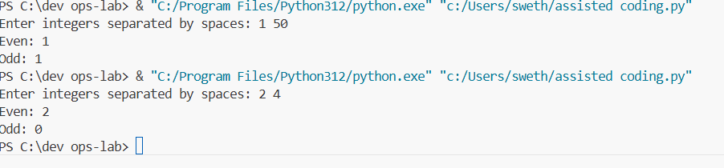
Task 3:
Task Description #3 (AI-Based Code Completion for Class
Attributes Validation)
Task: Use an AI tool to complete a Python class that validates user
input.
Expected Output:
• AI-generated class with validation logic.
• Verification of condition handling.
• Test cases for valid and invalid inputs.
Prompt:
# Python class User that validates age and email using conditional statements

Code:
class User:
def __init__(self, name: str, age, email: str):
self.name = name
self.age = age
self.email = email

def is_valid_age(self) -> bool:
try:
a = int(self.age)
except (ValueError, TypeError):
return False
if a < 0 or a > 120:
return False
return True

def is_valid_email(self) -> bool:
e = str(self.email).strip()
if "@" not in e or e.count("@") != 1:
return False
local, domain = e.split("@")
if not local or not domain:
return False
if "." not in domain or domain.startswith(".") or domain.endswith("."):
return False
if " " in e:
return False
return True

def validate(self) -> dict:
return {
"name": self.name,
"age_valid": self.is_valid_age(),
"email_valid": self.is_valid_email()
}

if __name__ == "__main__":
name = input("Name: ").strip()
age = input("Age: ").strip()
email = input("Email: ").strip()
user = User(name, age, email)
result = user.validate()
print(f"Age valid: {result['age_valid']}")
print(f"Email valid: {result['email_valid']}")
output :
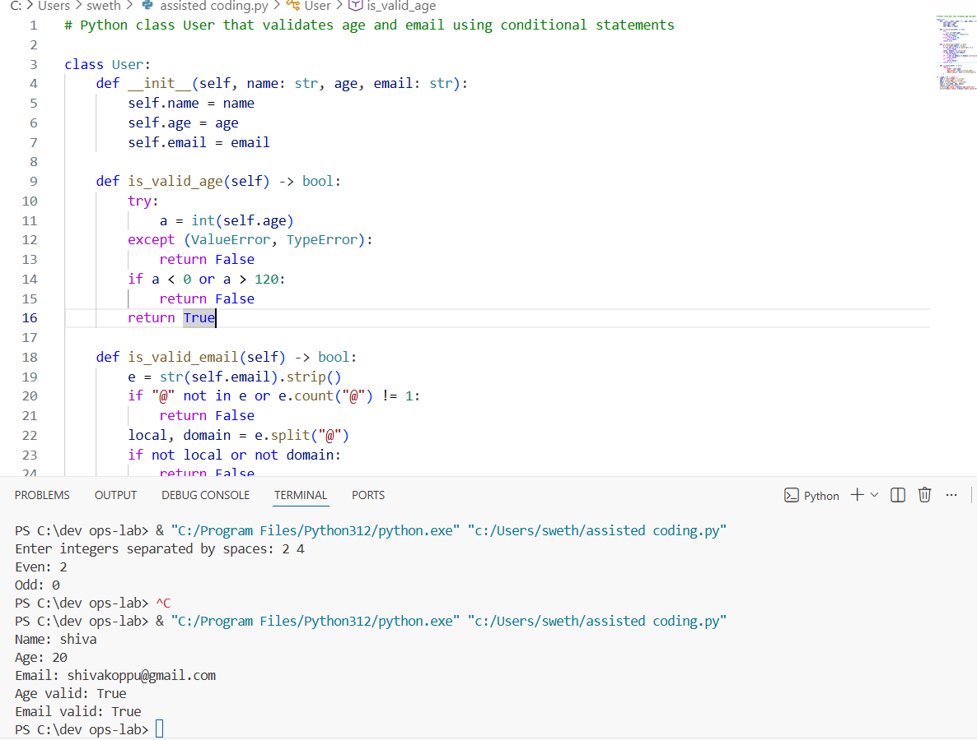

Task 4 :
Task Description #4 (AI-Based Code Completion for Classes)
Task: Use an AI code completion tool to generate a Python class for
managing student details.
Expected Output:
• AI-generated class code.
• Verification of correctness and completeness of class
structure.
• Minor manual improvements (if needed) with justification.

Prompt:
create a Python class Student with attributes like (name, roll number,
marks) and methods to calculate total and average marks
Code :
class Student:
def __init__(self, name, roll_number, marks=None):
self.name = name
self.roll_number = roll_number
self.marks = marks or []

def add_mark(self, mark):
self.marks.append(mark)

def total_marks(self):
return sum(self.marks)

def average_marks(self):
return self.total_marks() / len(self.marks) if self.marks else 0.0

def __repr__(self):
return f"Student(name={self.name!r}, roll={self.roll_number}, total={self.total_marks()}, avg={self.average_marks():.2f})"

if __name__ == "__main__":
s = Student("Alice", 1, [80, 90, 75])
print(s)
print("Total:", s.total_marks())
print("Average:", s.average_marks())
output:
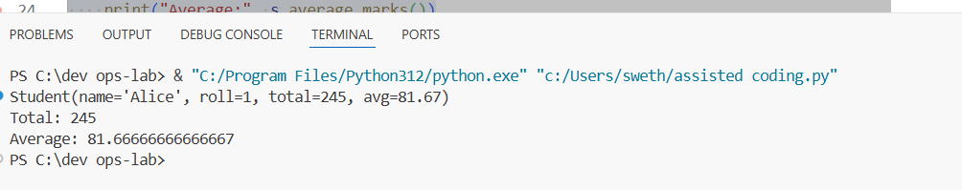
Task 5:
Task Description 5 (AI-Assisted Code Completion Review)
Task: Use an AI tool to generate a complete Python program using
classes, loops, and conditionals together.

Prompt:
#write a Python program for simple bank account system usingclass, loops, and conditional statements.”

Code:
class BankAccount:
def __init__(self, owner, acc_number, balance=0.0):
self.owner = owner
self.acc_number = acc_number
self.balance = float(balance)

def deposit(self, amount):
if amount <= 0:
return False, "Deposit amount must be positive."
self.balance += amount
return True, f"Deposited {amount:.2f}. New balance: {self.balance:.2f}"

def withdraw(self, amount):
if amount <= 0:
return False, "Withdrawal amount must be positive."
if amount > self.balance:
return False, "Insufficient funds."
self.balance -= amount
return True, f"Withdrew {amount:.2f}. New balance: {self.balance:.2f}"

def get_balance(self):
return self.balance

def __repr__(self):
return f"BankAccount(owner={self.owner!r}, acc_number={self.acc_number}, balance={self.balance:.2f})"

def main():
accounts = {}
next_acc = 1001

while True:
print("\n--- Simple Bank ---")
print("1. Create account")
print("2. Deposit")
print("3. Withdraw")
print("4. Check balance")
print("5. List accounts")
print("6. Exit")
choice = input("Choose an option (1-6): ").strip()

if choice == "1":
name = input("Account owner name: ").strip()
try:
initial = float(input("Initial deposit (0 for none): ") or 0)
except ValueError:
print("Invalid amount.")
continue
acc = BankAccount(name, next_acc, initial)
accounts[next_acc] = acc
print(f"Created account #{next_acc} for {name}.")
next_acc += 1

elif choice == "2":
try:
acc_no = int(input("Account number: "))
amt = float(input("Amount to deposit: "))
except ValueError:
print("Invalid input.")
continue
account = accounts.get(acc_no)
if not account:
print("Account not found.")
continue
ok, msg = account.deposit(amt)
print(msg)

elif choice == "3":
try:
acc_no = int(input("Account number: "))
amt = float(input("Amount to withdraw: "))
except ValueError:
print("Invalid input.")
continue
account = accounts.get(acc_no)
if not account:
print("Account not found.")
continue
ok, msg = account.withdraw(amt)
print(msg)

elif choice == "4":
try:
acc_no = int(input("Account number: "))
except ValueError:
print("Invalid account number.")
continue
account = accounts.get(acc_no)
if not account:
print("Account not found.")
continue
print(f"Balance for #{acc_no}: {account.get_balance():.2f}")

elif choice == "5":
if not accounts:
print("No accounts.")
else:
for a in accounts.values():
print(a)

elif choice == "6":
print("Goodbye.")
break

else:
print("Invalid choice. Enter 1-6.")

if __name__ == "__main__":
main()

output:
